**Functional Specifications – SAP ABAP Development**

**Document Control**

Document Information

|  |  |
| --- | --- |
|  | **Information** |
| Document Id |  |
| Document Name | SAP- CMS File Reports |
| Process Team | FINANCE |
| Document Owner | Mark Plotnick |
| Project Name | PANASONIC (Template Build) |
| Issue Date |  |
| Last Saved Date |  |
| File Name |  |

**Document History**

|  |  |  |  |
| --- | --- | --- | --- |
| **Version** | **Date** | **Description of Changes** | **Changed by** |
| 1.0 | 05/XX/2022 | Initial Draft |  |
| 1.1 | 05/XX/2022 | Review and Draft submission |  |
| 1,2 | 25/01/2023 | Updated as per agreed logic on 1/25/2023 review |  |
|  |  |  |  |

Document Approvals

|  |  |  |  |
| --- | --- | --- | --- |
| **Role** | **Name** | **Signature** | **Date** |
| Panasonic Leadership Approval |  |  |  |
| Overall/Business Project Manager | Muthu Kalyan |  |  |
| Overall/Business Business Area Rep. | Mark Plotnick |  |  |
| SAP Technical Project Manager | Surjit Bawa |  |  |
| SAP Technical Quality Officer |  |  |  |

Table of ***contents***

1 Development Summary 4

2 Scope Summary 5

2.1 Business Background (M) 5

2.2 High Level Business Requirements (M) 5

2.3 Link to Process Design Document 5

2.4 Overview of Solution (M) 5

2.5 Assumptions 5

3 Key Considerations 6

3.1 Risks/Issues (M) 6

3.2 Reference Programs 6

3.3 Dependency on Other Development or Interface (M) 6

3.4 Development Objects (per System) 6

3.5 Systems Involved (M) 6

3.6 Target User Group 7

4 Other considerations/Impacts 8

4.1 Volume of Data (M) 8

4.2 Cross Work Stream Impact (M) 8

4.3 Regression Impacts 8

4.4 Archiving Compatibility 8

4.5 Others 8

5 Development Scope 9

5.1 Outputs 9

5.1.1 Layout Details / Sample Formats (M) 9

5.1.2 Business Logic For Data Retrieval (M) 9

5.1.3 Triggering Mechanism (M) 10

5.1.4 Special Considerations 10

5.1.5 Error Handling (M) 10

5.1.6 Document Management System (DMS) requirement 10

5.1.7 Printing Special Considerations 10

5.2 Function Module / RFC / BAPI 11

5.2.1 Business Object 11

5.2.2 Input / Output Parameters(M) 11

5.2.3 Business Logic(M) 11

5.2.4 Error Handling(M) 12

5.3 Data Dictionary Objects 12

5.3.1 Custom Table 12

5.3.2 Search helps 13

5.4 Web Service 13

5.4.1 Configuration 14

5.4.2 Development Objects (M) 14

5.4.3 Authorizations (M) 14

5.4.4 Business Logic(M) 14

5.4.5 Error Handling(M) 14

5.5 Other Portal Considerations 14

6 Testing 15

6.1 Test Data 15

6.2 Business Test Condition 15

6.3 Unit Test Objective 15

6.4 Triggers 15

6.5 Test pre-conditions 15

6.6 Acceptance criteria 15

6.7 Unit Test Specification 15

7 Glossary 16

# Development Summary

|  |  |  |  |  |
| --- | --- | --- | --- | --- |
| **RICEFW ID# :** |  | **RICEFW Type:** | | Interface |
| **Title** : | SAP- CMS File Reports | | | | |
| **Function Consultant :** | Mark Plotnick | **Business Owner :** |  | | |
| **Contact Details :** |  |  |  | | |
| **Document Status :** | Draft | | | | |
| **Comments :** | CMS File Reports | | | | |

|  |  |  |  |
| --- | --- | --- | --- |
| **Business Criticality:** | Medium | **Complexity :** | Medium |
| **Type :** | Reports / Outputs | | |

# Scope Summary

## Business Background (M)

Panasonic of North America’s operating entities are invoiced regularly by Panasonic world wide factory suppliers for goods distributed and sold by PNA to their customers. These invoices translate to the factory suppliers open accounts receivables and PNA open accounts payables. PNA will book the invoices as accounts payable invoices and pay the factory suppliers. On a monthly basis PNA performs reconciliation by comparing PNA’s inter-company accounts payables against their factory suppliers’ accounts receivables.

**Detail Description**

ZCMS001 SAP- CMS File Reports

PNA’s factory suppliers forward the accounts receivable statements and corresponding unix file(s) as images to PNA which are stored on a UNIX file server. This information is used to reconcile PNA’s inter-company accounts payables against their factory suppliers’ accounts receivables. This custom development object provides the ability to view and print the factory suppliers’ accounts receivable statement and corresponding Unix file.

The change in the organization structure for the S/4 Hana will have no impact on this custom program. The Vision application structure will map the old organizations company code and business area to the new organization company code and business areas.

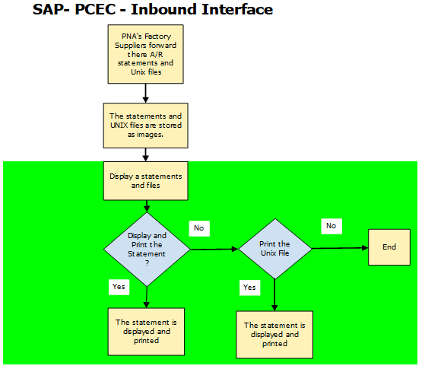

## High Level Business Requirements (M)

Business requirement is to provide a report for Reconciliation (DETAILED STATEMENT (ACCOUNTS RECEIVABLE)) on a dashboard using fiori.

Report shall provide the details about the PO Number, ship IV number Balance Forward, Sales, Collection, Balance.

Link to Process Design Document

## Overview of Solution (M)

PNA’s factory suppliers forward the accounts receivable statements and corresponding unix file(s) as images to PNA which are stored on a UNIX file server. This information is used to reconcile PNA’s inter-company accounts payables against their factory suppliers’ accounts receivables. This custom development object provides the ability to view and print the factory suppliers’ accounts receivable statement and corresponding Unix file.

## Assumptions

ZCMS001 SAP- CMS File Reports:

This custom development object presents a list of PNA’s factory suppliers’ accounts receivable statements for reconciliation purposes. The program provides the ability to view and print PNA’s factory suppliers’ accounts receivable statement and corresponding UNIX files. The program will provide the ability to perform the following functions:

* Present an initial screen that will list each PNA operating entities factory suppliers’ accounts receivable statement and UNIX file. The following information will be displayed:
  + Company Code
  + Factory Supplier Name, Month and Year
  + File Length
  + Creation Date
  + Creation Time
  + File Name
* Provide the ability to display and print the factory suppliers’ accounts receivable statements.
* Provide the ability to display and print the factory suppliers’ accounts receivable statements corresponding UNIX file.

# Key Considerations

|  |  |  |  |
| --- | --- | --- | --- |
| ***Issue*** | ***Owner*** | ***Target Date*** | ***Comments / Status*** |
|  |  |  |  |
|  |  |  |  |

## Risks/Issues (M)

None

## Reference Programs

“ZCMS001”

## Dependency on Other Development or Interface (M)

CMS will provide the connectors compatible with S4.

## Development Objects (per System)

|  |  |  |  |
| --- | --- | --- | --- |
| **S.No** | **System** | **Object Type** | **Description** |
|  |  |  |  |
|  |  |  |  |

## Systems Involved (M)

S/4 Hana

## Target User Group

Panasonic Finance User Group

# Other considerations/Impacts

BTP – Proposed AS-IS Solution



## Volume of Data (M)

N/A

## Cross Work Stream Impact (M)

N/A

## Regression Impacts

## Archiving Compatibility

## Others

# Development Scope

Complete for Interfaces and Conversions. Data accessed should be noted under data mapping in Description/Purpose.

|  |  |
| --- | --- |
| Inbound/Outbound | Inbound |
| Legacy Contact |  |
| Legacy Data Source | Payroll |
| Mode of Execution | Manual |
| Method of Handling | Manual |
| Dependency | Wheel test application |
| Data Cleaning Process | Wheel profile updates |
| Reconciliation Process | Ensure all records processed successfully |
| Include Data Consistency Check |  |
| Error Handling Method | Yes |
| Interface Process Log Details | Yes |
| Post Execution Notification Details |  |

**Proposed Solution**

**Program 1:** ZCMRERLG

After a batch session has been created in backhand, it process the batch session by using SM35, Program ZCMRERLG is a copy for SM35 where it prepares a file for all failed Jobs and send a group email.

**Solution**: Use standard way to analysis all failed job from SM35 (Fiori tile: Batch input Monitoring/Process Batch Input session) to download the job log in local file (Desktop).

**Failed Job Notification:**  This is standard functionality to Monitor and trigger email as notification for Failed Jobs.

**Email Trigger**: If required with details (AS IS) then do not delete ZCMRERLG and use as it is .

* **Solution A:** Use standard SM35 and remove the custom program if email functionality is not required and notification can be use
* **Solution B:** If email functionality is required than we need to go with same custom program .

**Program 2:** ZFILE_ARCHIVE_NEW

There is no Ztable , this program is only used to move file from one folder location to Archiving folder location

**Solution:** Proposed (BASIS review required): Use functional moulde ARCHIVFILE_SERVER_TO_SERVER

**Program 3:** ZCMS001

**Table in use:** ZCMS

ZCMS_file

**Solution:** Keep as it is

The program will provide the ability to perform the following functions:

* Present an initial screen that will list each PNA operating entities factory suppliers’ accounts receivable statement and UNIX file. The following information will be displayed:
  + Company Code
  + Factory Supplier Name, Month and Year
  + File Length
  + Creation Date
  + Creation Time
  + File Name
* Provide the ability to display and print the factory suppliers’ accounts receivable statements.
* Provide the ability to display and print the factory suppliers’ accounts receivable statements corresponding UNIX file.

## Outputs

### Layout Details / Sample Formats (M)

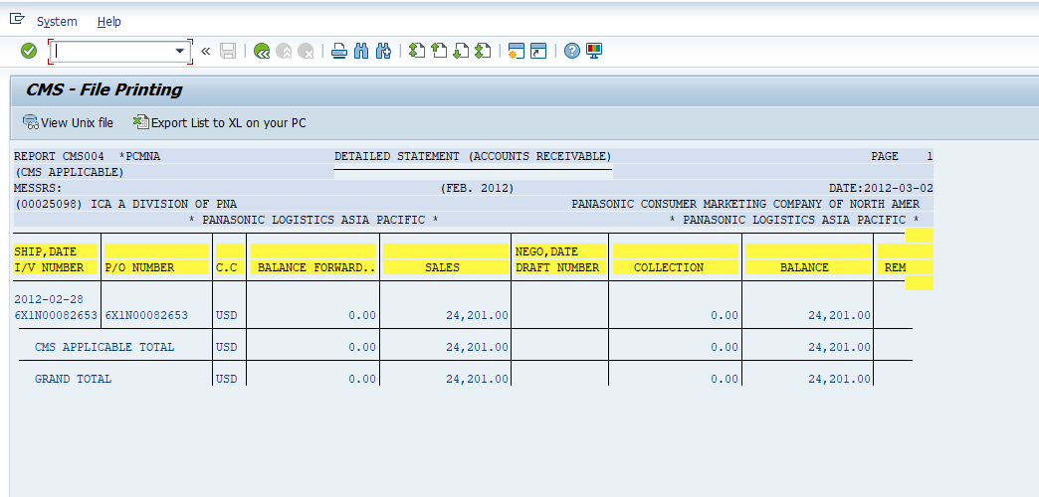

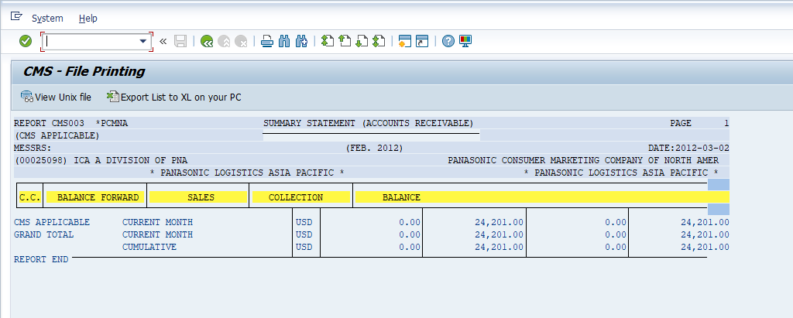

**Summary Layout**

### Business Logic For Data Retrieval (M)

### Triggering Mechanism (M)

### Special Considerations

### Error Handling (M)

Error message will be issued by the custom development object if the file transfer does not complete properly. The custom development object can be re-run as many times as is required.

***Insert Error Handing Detail attachment here if necessary:***

***The functional specification document is not complete without the security authorizations /error handling or unit test information***

### Document Management System (DMS) requirement

### Printing Special Considerations

#### Bulk printing (M)

#### Retained output

#### Envelope stuffing (M)

## Function Module / RFC / BAPI

### Business Object

*N/A*

**Desired screen design (selection possibilities): attach screen shot if needed**

### Business Logic(M)

### Error Handling(M)

## Data Dictionary Objects

**Ignore if No Dictionalt Objects are involved**

### Custom Table

**\*** CUSTOM Z TABLE – COPY FROM CQ4 SYSTEM (MAINTENANCE VIEW IN SM30 REQUIRED)

#### Table Type (M)

#### Number of Records (M)

#### Field List (M)

|  |  |  |  |  |  |
| --- | --- | --- | --- | --- | --- |
| **S.No** | **Field name** | **Key Field** | **Field Type** | **Field Length** | **Comments** |
|  |  |  |  |  |  |
|  |  |  |  |  |  |
|  |  |  |  |  |  |

#### Table Maintenance (M)

#### Authorisations (M)

### Search helps

**Ignore if no search Help Creation involved**

#### Data Source(M)

#### Search Fields(M)

#### Output and Selectable Fields(M)

## Web Service

**Ignore if this in Not a WebService**

### Configuration

### Development Objects (M)

### Authorizations (M)

Please specify security, authorization group, authorization object with activity level details, report tree level security etc.The user roles that would be accessing this functionality will have to be clearly identified upfront.

### Business Logic(M)

### Error Handling(M)

## Other Portal Considerations

# Testing

## Test Data

*<Provide Details or Screen Shots and Directions to create the Test Data>*

## Business Test Condition

*< What is the Business/Functional Test conditions, Critreria based on which you think this development as per ecpations and correct>*

## Unit Test Objective

*< This Section Can be leveraged in completx developments, multiple objects like varous function modules and Repository objects are built and you would like define the Succes Criteria invidually to eact object>*

## Triggers

## Test pre-conditions

## Acceptance criteria

## Unit Test Specification

|  |  |  |  |  |
| --- | --- | --- | --- | --- |
| ***Step*** | ***Step Description*** | ***Expected Results*** | ***Actual Results*** | ***Comments (Pass/Fail)*** |
|  | ***Test Case Description*** | | | |
| 1 | Check the file in AL11 path à /interface/edi/out | File is visible in the directory location | As expected | Pass |
| 2 | Enter Tr. Code ZCMS | CMS-File Printing screen appears | As expected | Pass |
| 3 | Check the Report Name, Date created and company code | File name in AL11 directory must match the file name in the ZCMS output. | As expected. | Pass |
|  | Double click on the required report list | The output must be displayed in the below format:  SHIP, DATE I/V NUMBER  P/O NUMBER  C.C  BALANCE FORWARD  SALES  NEGO, DATE DRAFT NUMBER  COLLECTION  BALANCE  REM | Results as expected | Pass |

1

2

3

4

# Glossary